* My sample class PasswordValidator.java
* Code ss:

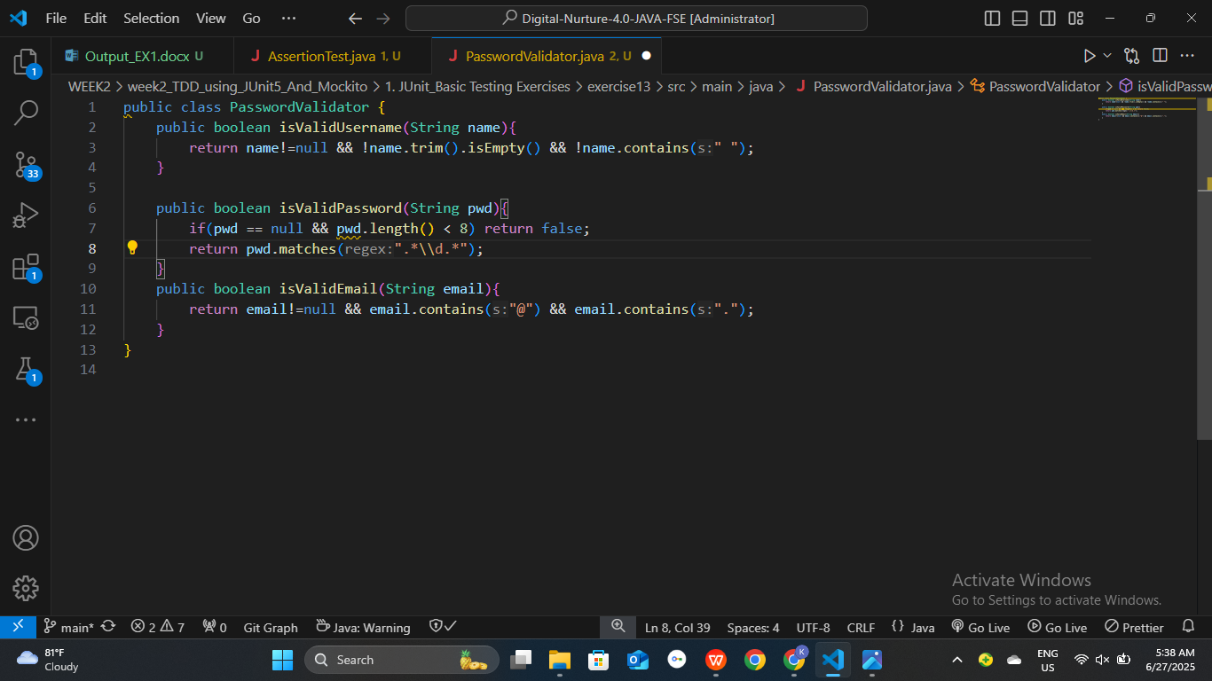

* My test class PasswordValidatorTest.java contains
  + @Before,
  + @After methods
  + Follows Arrange-Act-Assert structure inside test methods

**Code ss:**

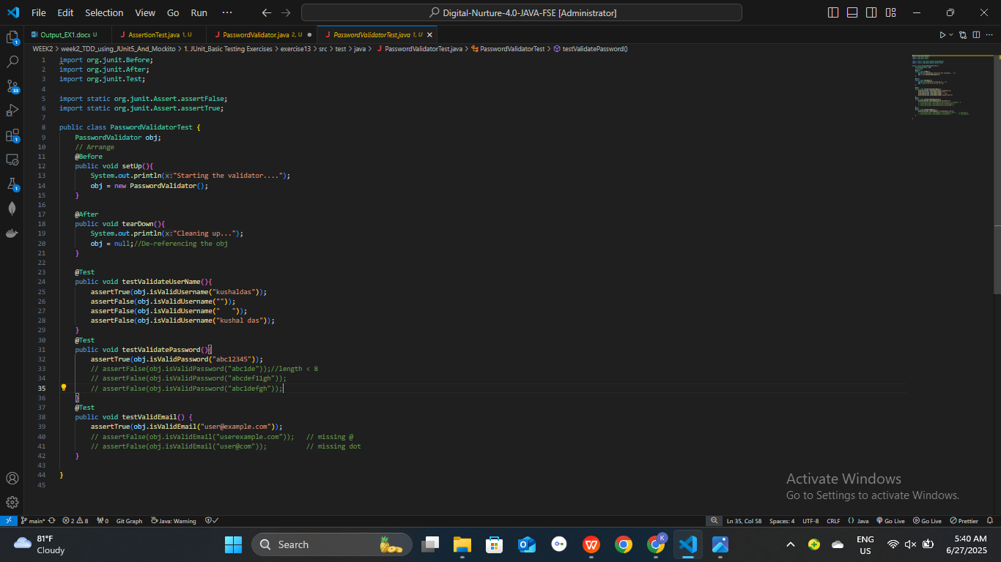

**Test Output in terminal:** without failure – mvn test

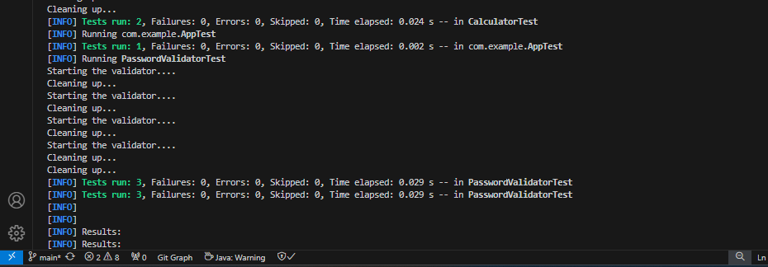

**Test Output in terminal:** with failure – mvn test

